**Lab Exercises**

Class: 软件1802班 Name: 范晨光 StuID： 201816040213

Date: 2019.11.28 Score:

**Lab Exercise 1 — Account Hierarchy**

**I Lab Objectives**

In this lab, you will practice:

1. Using inheritance to create an account hierarchy that includes an Account class, a SavingsAccount class and a CheckingAccount class.
2. Using private data members to limit access to data members.
3. Redefining base-class member functions in a derived class.

**II Description of the Problem(译文见教材P387 11.10)**

Create an inheritance hierarchy that a bank might use to represent customers’ bank accounts. All customers at this bank can deposit (i.e., credit) money into their accounts and withdraw (i.e., debit) money from their accounts. More specific types of accounts also exist. Savings accounts, for instance, earn interest on the money they hold. Checking accounts, on the other hand, charge a fee per transaction (i.e., credit or debit).

Create an inheritance hierarchy containing base class Account and derived classes SavingsAccount and CheckingAccount that inherit from class Account. Base class Account should include one data member of type double to represent the account balance. The class should provide a constructor that receives an initial balance and uses it to initialize the data member. The constructor should validate the initial balance to ensure that it is greater than or equal to 0.0. If not, the balance should be set to 0.0 and the constructor should display an error message, indicating that the initial balance was invalid. The class should provide three member functions. Member function credit should add an amount to the current balance. Member function debit should withdraw money from the Account and ensure that the debit amount does not exceed the Account’s balance. If it does, the balance should be left unchanged and the function should print the message "Debit amount exceeded account balance." Member function getBalance should return the current balance.

Derived class SavingsAccount should inherit the functionality of an Account, but also include a data member of type double indicating the interest rate (percentage) assigned to the Account. SavingsAccount’s constructor should receive the initial balance, as well as an initial value for the SavingsAccount’s interest rate. SavingsAccount should provide a public member function calculateInterest that returns a double indicating the amount of interest earned by an account. Member function calculateInterest should determine this amount by multiplying the interest rate by the account balance. [Note: SavingsAccount should inherit member functions credit and debit as is without redefining them.]

Derived class CheckingAccount should inherit from base class Account and include an additional data member of type double that represents the fee charged per transaction. CheckingAccount’s constructor should receive the initial balance, as well as a parameter indicating a fee amount. Class CheckingAccount should redefine member functions credit and debit so that they subtract the fee from the account balance whenever either transaction is performed successfully. CheckingAccount’s versions of these functions should invoke the base-class Account version to perform the updates to an account balance. CheckingAccount’s debit function should charge a fee only if money is actually withdrawn (i.e., the debit amount does not exceed the account balance). [*Hint*: Define Account’s debit function so that it returns a bool indicating whether money was withdrawn. Then use the return value to determine whether a fee should be charged.]

After defining the classes in this hierarchy, write a program that creates objects of each class and tests their member functions. Add interest to the SavingsAccount object by first invoking its calculateInterest function, then passing the returned interest amount to the object’s credit function.

**III Sample Output**

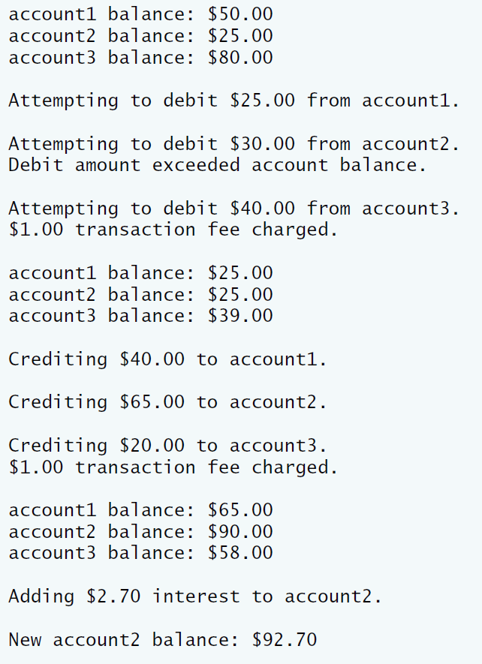

**IV Problem-Solving Tips**

1. Each derived class constructor, SavingsAccount and CheckingAccount, should call the Account constructor explicitly.
2. Do not use the debit member function inside the chargeFee member function, because the debit member function would then call the chargeFee member function, leading to infinite recursion. Instead use the inherited *get* and *set* functions for the account balance.

**V Your Solution**

**// Lab 1: Account.h**

**// Definition of Account class.**

**#ifndef ACCOUNT_H**

**#define ACCOUNT_H**

**class Account**

**{**

**public:**

**Account( double ); // constructor initializes balance**

**void credit( double ); // add an amount to the account balance**

**bool debit( double ); // subtract an amount from the account balance**

**void setBalance( double ); // sets the account balance**

**double getBalance(); // return the account balance**

**private:**

**double balance; // data member that stores the balance**

**}; // end class Account**

**#endif**

**// Lab 1: Account.cpp**

**// Member-function definitions for class Account.**

**#include <iostream>**

**using namespace std;**

**#include "Account.h" // include definition of class Account**

**// Account constructor initializes data member balance**

**Account::Account( double initialBalance )**

**{**

**// if initialBalance is greater than or equal to 0.0, set this value**

**// as the balance of the Account**

**if ( initialBalance >= 0.0 )**

**balance = initialBalance;**

**else // otherwise, output message and set balance to 0.0**

**{**

**cout << "Error: Initial balance cannot be negative." << endl;**

**balance = 0.0;**

**} // end if...else**

**} // end Account constructor**

**// credit (add) an amount to the account balance**

**void Account::credit( double amount )**

**{**

**balance = balance + amount; // add amount to balance**

**} // end function credit**

**// debit (subtract) an amount from the account balance**

**// return bool indicating whether money was debited**

**bool Account::debit( double amount )**

**{**

**if ( amount > balance ) // debit amount exceeds balance**

**{**

**cout << "Debit amount exceeded account balance." << endl;**

**return false;**

**} // end if**

**else // debit amount does not exceed balance**

**{**

**balance = balance - amount;**

**return true;**

**} // end else**

**} // end function debit**

**// set the account balance**

**void Account::setBalance( double newBalance )**

**{**

**balance = newBalance;**

**} // end function setBalance**

**// return the account balance**

**double Account::getBalance()**

**{**

**return balance;**

**} // end function getBalance**

**// Lab 1: CheckingAccount.h**

**// Definition of CheckingAccount class.**

**#ifndef CHECKING_H**

**#define CHECKING_H**

**#include "Account.h"**

**class CheckingAccount : public Account**

**{**

**public:**

**// constructor initializes balance and transaction fee**

**CheckingAccount( double, double );**

**void credit( double ); // add an amount to the account balance**

**bool debit( double ); // subtract an amount from the account balance**

**private:**

**double transactionFee;**

**// utility function to charge fee**

**double chargeFee( );**

**}; // end class CheckingAccount**

**#endif**

**// Lab 1: CheckingAccount.cpp**

**// Member-function definitions for class CheckingAccount.**

**#include <iostream>**

**using namespace std**

**#include "CheckingAccount.h" // CheckingAccount class definition**

**// constructor initializes balance and transaction fee**

**CheckingAccount::CheckingAccount( double bal, double fee )**

**:Account( bal )**

**{**

**transactionFee = fee;**

**}**

**// credit (add) an amount to the account balance and charge fee**

**void CheckingAccount::credit( double amount )**

**{**

**setBalance( getBalance() + amount - transactionFee); // add amount to balance**

**} // end function credit**

**// debit (subtract) an amount from the account balance and charge fee**

**bool CheckingAccount::debit( double amount )**

**{**

**if ( !Account::debit(amount) ) // debit amount exceeds balance**

**{**

**return false;**

**} // end if**

**else // debit amount does not exceed balance**

**{**

**setBalance( chargeFee() );**

**return true;**

**} // end else**

**} // end function debit**

**// subtract transaction fee**

**double CheckingAccount::chargeFee( )**

**{**

**return getBalance() - transactionFee;**

**} // end function chargeFee**

**// Lab 1: SavingsAccount.h**

**// Definition of SavingsAccount class.**

**#ifndef SAVINGS_H**

**#define SAVINGS_H**

**#include "Account.h"**

**class SavingsAccount : public Account**

**{**

**public:**

**// constructor initializes balance and interest rate**

**SavingsAccount( double, double );**

**double calculateInterest( );**

**private:**

**double interestRate;**

**}; // end class SavingsAccount**

**#endif**

**// Lab 1: SavingsAccount.cpp**

**// Member-function definitions for class SavingsAccount.**

**#include "SavingsAccount.h" // SavingsAccount class definition**

**// constructor initializes balance and interest rate**

**SavingsAccount ::SavingsAccount( double bal, double irate )**

**:Account( bal )**

**{**

**interestRate = irate;**

**}**

**// return the amount of interest earned**

**double SavingsAccount::calculateInterest( )**

**{**

**return getBalance() * interestRate;**

**} // end function calculateInterest**

**// Lab 1: bankAccounts.cpp**

**// Test program for Account hierarchy.**

**#include <iostream>**

**#include <iomanip>**

**using namespace std;**

**#include "Account.h" // Account class definition**

**#include "SavingsAccount.h" // SavingsAccount class definition**

**#include "CheckingAccount.h" // CheckingAccount class definition**

**int main()**

**{**

**Account account1( 50.0 ); // create Account object**

**SavingsAccount account2( 25.0, .03 ); // create SavingsAccount object**

**CheckingAccount account3( 80.0, 1.0 ); // create CheckingAccount object**

**cout << fixed << setprecision( 2 );**

**// display initial balance of each object**

**cout << "account1 balance: $" << account1.getBalance() << endl;**

**cout << "account2 balance: $" << account2.getBalance() << endl;**

**cout << "account3 balance: $" << account3.getBalance() << endl;**

**cout << "\nAttempting to debit $25.00 from account1." << endl;**

**account1.debit( 25.0 ); // try to debit $25.00 from account1**

**cout << "\nAttempting to debit $30.00 from account2." << endl;**

**account2.debit( 30.0 ); // try to debit $30.00 from account2**

**cout << "\nAttempting to debit $40.00 from account3." << endl;**

**account3.debit( 40.0 ); // try to debit $40.00 from account3**

**// display balances**

**cout << "\naccount1 balance: $" << account1.getBalance() << endl;**

**cout << "account2 balance: $" << account2.getBalance() << endl;**

**cout << "account3 balance: $" << account3.getBalance() << endl;**

**cout << "\nCrediting $40.00 to account1." << endl;**

**account1.credit( 40.0 ); // credit $40.00 to account1**

**cout << "\nCrediting $65.00 to account2." << endl;**

**account2.credit( 65.0 ); // credit $65.00 to account2**

**cout << "\nCrediting $20.00 to account3." << endl;**

**account3.credit( 20.0 ); // credit $20.00 to account3**

**// display balances**

**cout << "\naccount1 balance: $" << account1.getBalance() << endl;**

**cout << "account2 balance: $" << account2.getBalance() << endl;**

**cout << "account3 balance: $" << account3.getBalance() << endl;**

**// add interest to SavingsAccount object account2**

**//a variable interestEarned and assign it the interest account2 should earn**

**double interestEarned = account2.calculateInterest();**

**cout << "\nAdding $" << interestEarned << " interest to account2."**

**<< endl;**

**// a statement to credit the interest to account2's balance**

**account2.setBalance( account2.getBalance() + account2.calculateInterest() );**

**cout << "\nNew account2 balance: $" << account2.getBalance() << endl;**

**} // end main**

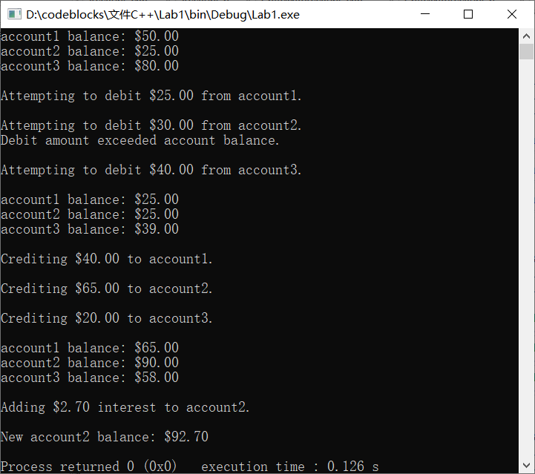**Lab Exercise 2 — Composition**

**I Lab Objectives**

In this lab, you will practice:

1. Using composition to incorporate one class’s members into another class.

The follow-up question and activity also will give you practice:

1. Comparing inheritance and composition.

**II Description of the Problem (译文见P386 11.3)**

Many programs written with inheritance could be written with composition instead, and vice versa. Rewrite class BasePlusCommissionEmployee of the CommissionEmploy ee–BasePlusCommissionEmployee hierarchy to use composition rather than inheritance.

**III Sample Output**

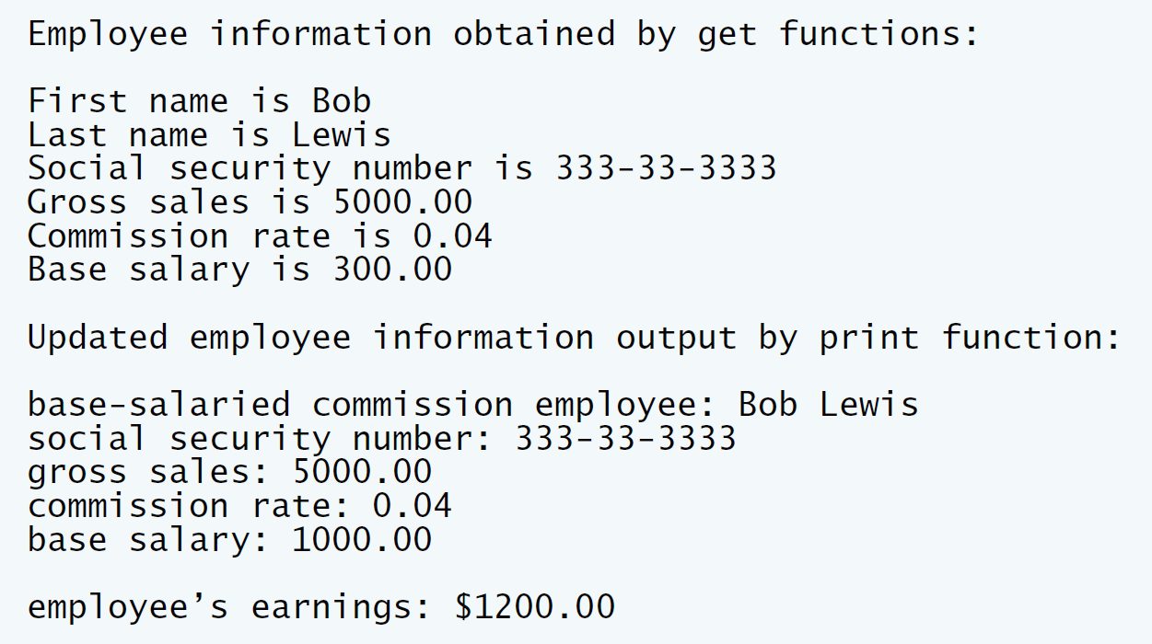

**IV Problem-Solving Tips**

1. To implement BasePlusCommissionEmployee using composition, include a ComissionEmployee object as a data member in the BasePlusCommission Employee class.
2. To access a member of CommissionEmployee inside a member function of BasePlusCommissionEmployee, it must be preceded by the name of the CommissionEmployee object and the dot operator.
3. Most of BasePlusCommissionEmployee’s member functions will be implemented by simply calling the same member function from the CommissionEmployee object; this is known as “delegation.”

**V Your Solution**

**// Lab 2: CommissionEmployee.h**

**// CommissionEmployee class definition represents a commission employee.**

**#ifndef COMMISSION_H**

**#define COMMISSION_H**

**#include <string> // C++ standard string class**

**using namespace std;**

**class CommissionEmployee**

**{**

**public:**

**CommissionEmployee( const string &, const string &, const string &,**

**double = 0.0, double = 0.0 );**

**void setFirstName( const string & ); // set first name**

**string getFirstName() const; // return first name**

**void setLastName( const string & ); // set last name**

**string getLastName() const; // return last name**

**void setSocialSecurityNumber( const string & ); // set SSN**

**string getSocialSecurityNumber() const; // return SSN**

**void setGrossSales( double ); // set gross sales amount**

**double getGrossSales() const; // return gross sales amount**

**void setCommissionRate( double ); // set commission rate (percentage)**

**double getCommissionRate() const; // return commission rate**

**double earnings() const; // calculate earnings**

**void print() const; // print CommissionEmployee object**

**private:**

**string firstName;**

**string lastName;**

**string socialSecurityNumber;**

**double grossSales; // gross weekly sales**

**double commissionRate; // commission percentage**

**}; // end class CommissionEmployee**

**#endif**

**// Lab 2: CommissionEmployee.cpp**

**// Class CommissionEmployee member-function definitions.**

**#include <iostream>**

**using namespace std;**

**#include "CommissionEmployee.h" // CommissionEmployee class definition**

**// constructor**

**CommissionEmployee::CommissionEmployee(**

**const string &first, const string &last, const string &ssn,**

**double sales, double rate )**

**{**

**firstName = first; // should validate**

**lastName = last; // should validate**

**socialSecurityNumber = ssn; // should validate**

**setGrossSales( sales ); // validate and store gross sales**

**setCommissionRate( rate ); // validate and store commission rate**

**} // end CommissionEmployee constructor**

**// set first name**

**void CommissionEmployee::setFirstName( const string &first )**

**{**

**firstName = first; // should validate**

**} // end function setFirstName**

**// return first name**

**string CommissionEmployee::getFirstName() const**

**{**

**return firstName;**

**} // end function getFirstName**

**// set last name**

**void CommissionEmployee::setLastName( const string &last )**

**{**

**lastName = last; // should validate**

**} // end function setLastName**

**// return last name**

**string CommissionEmployee::getLastName() const**

**{**

**return lastName;**

**} // end function getLastName**

**// set social security number**

**void CommissionEmployee::setSocialSecurityNumber( const string &ssn )**

**{**

**socialSecurityNumber = ssn; // should validate**

**} // end function setSocialSecurityNumber**

**// return social security number**

**string CommissionEmployee::getSocialSecurityNumber() const**

**{**

**return socialSecurityNumber;**

**} // end function getSocialSecurityNumber**

**// set gross sales amount**

**void CommissionEmployee::setGrossSales( double sales )**

**{**

**grossSales = ( sales < 0.0 ) ? 0.0 : sales;**

**} // end function setGrossSales**

**// return gross sales amount**

**double CommissionEmployee::getGrossSales() const**

**{**

**return grossSales;**

**} // end function getGrossSales**

**// set commission rate**

**void CommissionEmployee::setCommissionRate( double rate )**

**{**

**commissionRate = ( rate > 0.0 && rate < 1.0 ) ? rate : 0.0;**

**} // end function setCommissionRate**

**// return commission rate**

**double CommissionEmployee::getCommissionRate() const**

**{**

**return commissionRate;**

**} // end function getCommissionRate**

**// calculate earnings**

**double CommissionEmployee::earnings() const**

**{**

**return commissionRate * grossSales;**

**} // end function earnings**

**// print CommissionEmployee object**

**void CommissionEmployee::print() const**

**{**

**cout << "commission employee: " << firstName << ' ' << lastName**

**<< "\nsocial security number: " << socialSecurityNumber**

**<< "\ngross sales: " << grossSales**

**<< "\ncommission rate: " << commissionRate;**

**} // end function print**

**// Lab 2: BasePlusCommissionEmployee.h**

**// BasePlusCommissionEmployee class using composition.**

**#ifndef BASEPLUS_H**

**#define BASEPLUS_H**

**#include <string> // C++ standard string class**

**using namespace std;**

**#include "CommissionEmployee.h" // CommissionEmployee class definition**

**class BasePlusCommissionEmployee**

**{**

**public:**

**BasePlusCommissionEmployee( const string &, const string &,**

**const string &, double = 0.0, double = 0.0, double = 0.0 );**

**void setFirstName( const string & ); // set first name**

**string getFirstName() const; // return first name**

**void setLastName( const string & ); // set last name**

**string getLastName() const; // return last name**

**void setSocialSecurityNumber( const string & ); // set SSN**

**string getSocialSecurityNumber() const; // return SSN**

**void setGrossSales( double ); // set gross sales amount**

**double getGrossSales() const; // return gross sales amount**

**void setCommissionRate( double ); // set commission rate**

**double getCommissionRate() const; // return commission rate**

**void setBaseSalary( double ); // set base salary**

**double getBaseSalary() const; // return base salary**

**double earnings() const; // calculate earnings**

**void print() const; // print BasePlusCommissionEmployee object**

**private:**

**double baseSalary; // base salary**

**CommissionEmployee ce; //CommissionEmployee data member**

**}; // end class BasePlusCommissionEmployee**

**#endif**

**// Lab 2: BasePlusCommissionEmployee.cpp**

**// Member-function definitions of class BasePlusCommissionEmployee**

**// using composition.**

**#include <iostream>**

**using namespace std;**

**// BasePlusCommissionEmployee class definition**

**#include "BasePlusCommissionEmployee.h"**

**#include "CommissionEmployee.h"**

**// constructor**

**BasePlusCommissionEmployee::BasePlusCommissionEmployee(**

**const string &first, const string &last, const string &ssn,**

**double sales, double rate, double salary )**

**// initialize composed object**

**: ce( first, last, ssn, sales, rate )//Initialize the commissionEmployee data member**

**{**

**setBaseSalary( salary ); // validate and store base salary**

**} // end BasePlusCommissionEmployee constructor**

**// set commission employee's first name**

**void BasePlusCommissionEmployee::setFirstName( const string &first )**

**{**

**ce.setFirstName( first );**

**} // end function setFirstName**

**// return commission employee's first name**

**string BasePlusCommissionEmployee::getFirstName() const**

**{**

**return ce.getFirstName();**

**} // end function getFirstName**

**// set commission employee's last name**

**void BasePlusCommissionEmployee::setLastName( const string &last )**

**{**

**ce.setLastName( last );**

**} // end function setLastName**

**// return commission employee's last name**

**string BasePlusCommissionEmployee::getLastName() const**

**{**

**return ce.getLastName();**

**} // end function getLastName**

**// set commission employee's social security number**

**void BasePlusCommissionEmployee::setSocialSecurityNumber( const string &ssn )**

**{**

**ce.setSocialSecurityNumber( ssn );**

**} // end function setSocialSecurityNumber**

**// return commission employee's social security number**

**string BasePlusCommissionEmployee::getSocialSecurityNumber() const**

**{**

**return ce.getSocialSecurityNumber();**

**} // end function getSocialSecurityNumber**

**// set commission employee's gross sales amount**

**void BasePlusCommissionEmployee::setGrossSales( double sales )**

**{**

**ce.setGrossSales( sales );**

**} // end function setGrossSales**

**// return commission employee's gross sales amount**

**double BasePlusCommissionEmployee::getGrossSales() const**

**{**

**return ce.getGrossSales();**

**} // end function getGrossSales**

**// set commission employee's commission rate**

**void BasePlusCommissionEmployee::setCommissionRate( double rate )**

**{**

**ce.setCommissionRate( rate );**

**} // end function setCommissionRate**

**// return commission employee's commission rate**

**double BasePlusCommissionEmployee::getCommissionRate() const**

**{**

**return ce.getCommissionRate();**

**} // end function getCommissionRate**

**// set base salary**

**void BasePlusCommissionEmployee::setBaseSalary( double salary )**

**{**

**baseSalary = ( salary < 0.0 ) ? 0.0 : salary;**

**} // end function setBaseSalary**

**// return base salary**

**double BasePlusCommissionEmployee::getBaseSalary() const**

**{**

**return baseSalary;**

**} // end function getBaseSalary**

**// calculate earnings**

**double BasePlusCommissionEmployee::earnings() const**

**{**

**return getBaseSalary() + ce.earnings();**

**} // end function earnings**

**// print BasePlusCommissionEmployee object**

**void BasePlusCommissionEmployee::print() const**

**{**

**cout << "base-salaried ";**

**// invoke composed CommissionEmployee object's print function**

**ce.print();**

**cout << "\nbase salary: " << getBaseSalary();**

**} // end function print**

**// Lab 2: composition.cpp**

**// Testing class BasePlusCommissionEmployee.**

**#include <iostream>**

**#include <iomanip>**

**using namespace std;**

**// BasePlusCommissionEmployee class definition**

**#include "BasePlusCommissionEmployee.h"**

**int main()**

**{**

**// instantiate BasePlusCommissionEmployee object**

**BasePlusCommissionEmployee**

**employee( "Bob", "Lewis", "333-33-3333", 5000, .04, 300 );**

**// set floating-point output formatting**

**cout << fixed << setprecision( 2 );**

**// get commission employee data**

**cout << "Employee information obtained by get functions: \n"**

**<< "\nFirst name is " << employee.getFirstName()**

**<< "\nLast name is " << employee.getLastName()**

**<< "\nSocial security number is "**

**<< employee.getSocialSecurityNumber()**

**<< "\nGross sales is " << employee.getGrossSales()**

**<< "\nCommission rate is " << employee.getCommissionRate()**

**<< "\nBase salary is " << employee.getBaseSalary() << endl;**

**employee.setBaseSalary( 1000 ); // set base salary**

**cout << "\nUpdated employee information output by print function: \n"**

**<< endl;**

**employee.print(); // display the new employee information**

**// display the employee's earnings**

**cout << "\n\nEmployee's earnings: $" << employee.earnings() << endl;**

**} // end main**

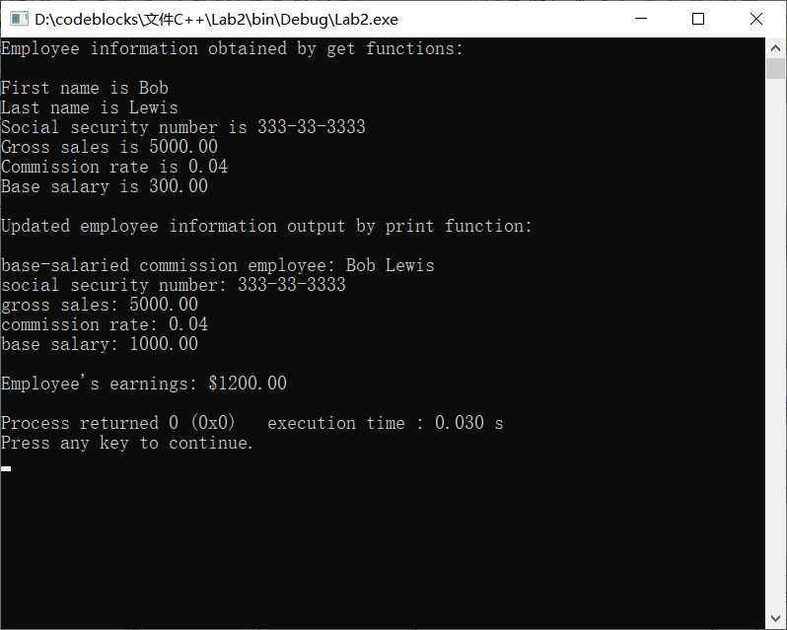**VI Follow-Up Questions and Activities**

1. Assess the relative merits of the two approaches for designing classes Commission-Employee and BasePlusCommissionEmployee, as well as for object-oriented programs in general. Which approach is more natural? Why?

组合优点：不破坏封装性，类与类之间松耦合；具有比较好的可扩展性；

继承优点：创建派生类对象时不需要建立基类对象；派生类能自动继承基类的接口；避免错误扩散；

虽然继承可以避免代码冗杂问题，但我认为组合更加自然，因为组合不破坏类的封装性，更加符合面向对象的编程原则。